The John Mills MBE Education Award
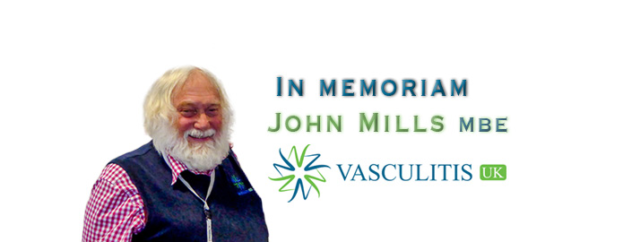

Background
Dr John Mills was a Bakewell dentist who was diagnosed with Granulomatosis with Polyangiitis in 2001. Following his diagnosis, he undertook many roles including becoming a member of the British Society of Rheumatology (BSR) and British Health Professionals in Rheumatology (BHPR) guideline panel, Member of the Board of Trustees at the Genetic Alliance UK and Rare Disease UK, and a patient representative for vasculitis for European Organisation for Rare Diseases (EURODIS)-Rare Disease Europe.
In 2009, John became the Chair of the Stuart Strange Vasculitis Trust (SSVT), which became Vasculitis UK in 2010. Since then, John served as Vasculitis Patient Representative for the UK and Ireland Vasculitis Study Group (UKIVAS) and European League Against Rheumatology (EULAR).
John was the Patient Public Voice for NHS England Specialised Rheumatology Services for 6 years and was also part of the NICE appraisal for Rituximab in ANCA vasculitis.
In 2023 John was awarded an MBE for services to People with Rare Diseases through his role as Chair and Director of Operations of Vasculitis UK in recognition of his tireless work for the vasculitis community.
John worked unremittingly to improve vasculitis patient care, championing education of both healthcare professionals and patients and supporting vasculitis research across centres in the UK. His undoubted achievements and successes were enhanced by the devotion and dedication of his wife Susan who continues to champion this cause.
In recognition of the legacy left by John “The John Mills MBE Education Award” seeks to recognise innovative educational projects which have made a difference to those living with or caring for people with vasculitis.

The Award
£500 will be awarded to the prize winner alongside the opportunity to attend the annual UKIVAS training course to present this educational work. The award winner will be posted on the Vasculitis UK website together with a summary of their project.

Application criteria
This award is open to applications from any healthcare professional or non-professional (e.g. patient/ carer) who has undertaken educational projects or educational initiatives in the field of vasculitis. Applications will be considered from groups or individuals. Projects can be nominated for this award by others.

Applications with the following aspects will be viewed favourably:
- Completed projects (or those with significant progress underway)
- Collaborative projects e.g. multi-disciplinary involvement, cross centre collaboration
- Ability to demonstrate positive impact of the educational activity on vasculitis patient care.
- Projects not previously presented or published elsewhere.

Examples of educational projects that might be eligible include: -
- Creating training programmes, workshops or meetings for clinical staff managing vasculitis.
- The design of disease specific educational documentation or information leaflets for staff and / or patients.
- Hosting or facilitating a dedicated vasculitis fellowship or trainee opportunity for any clinical discipline.
- Designing an online / remote access or interactive training platform.
- Hosting patient education days

Review and selection process.
Applications will be reviewed annually in the autumn by:
- Vasculitis UK representative(s)
- UKIVAS Education committee
Please use the attached form to submit your application.
For further questions about the award e.g. time frames or suitability of projects for applying please contact: nina.brown@nca.nhs.uk

The John Mills MBE Education Award
Application Form
(500 words maximum)
Date:
Project title:
Rationale for the educational initiative:
Summary of educational initiative:
Outcomes:

Please email completed forms to:- nina.brown@nca.nhs.uk
For office use only:
Date received: Date of review: Approved: Yes / no

